**PV182**

**Zdroje:**

**Prednášky Human Computer Interaction, Fotis Liarokapis**

**Wikipedia :^)**

**Test sa nemusí skladať presne z týchto otázok**

**_______________**

**Introduction**

***What is human-computer interaction? What are the three paradigms of HCI? What are the mediums of advanced HCI?***

Definition:

Human–computer interaction (commonly referred to as HCI) researches the design and use of computer technology, focused on the interfaces between people (users) and computers. Researchers in the field of HCI both observe the ways in which humans interact with computers and design technologies that let humans As a field of research, human-computer interaction is situated at the intersection of computer science, behavioral sciences, design, media studies, and several other fields of study.

3 paradigms:

1. Human factors (engineering) — interaction as a form of man and machine “unification”, attempts to optimize the fit between user and computer
2. Classical cognitivism (information) — interaction as information transfer, attempts to optimize and improve information transfer between human and computer
3. Embodied cognition (interaction) — interaction as phenomenologically situated, support for situated action in the world

they’re just different views on HCI, none of them are objectively better than the others

Advanced media: VR, AR, brain-computer interfaces, HUD, voice controls…

***Why is it important to consider product usability in a project? Which informatics professions make use of usability engineering ?***

Computers got cheaper than they were in the past, number of users increased and the user is now put above all else. Most users are not computer pros and will not accept products with bad interfaces. Usability engineering is software engineering, setting improper user requirements and neglecting usability tests will cost a lot of money later in the project.

***What are typical errors in completed design that did not take into account the principles of usability ? Comment, give an example from practice.***

-design founded on incorrect requirements

-has inappropriate dialogue flow

-is not easily used

-is not tested until too late

***UI design is based on the following principles:***

1. ***understanding users and their tasks***
2. ***participatory design***
3. ***design of visual interfaces***
4. ***design principles based on heuristics and recommendations***

***Explain these issues and sketch related techniques and theoretical foundations.***

1. We have to know what our user are like, what their expectations are, how they use our product to achieve their desired goals – developing tasks, evaluating design through task-centered walkthroughs
2. User is an active part of the design process, gives constant feedback on early design prototypes (sketches etc.), observing the user to detect problems - user-centered design
3. studying the design of everyday, established things, figuring out what makes them work; studying metaphors and represetnations of functions/actions on the screen; the graphic design and placement of components on screen
4. using guidelines and heuristics to discovers flaws in our design

***What are the human characteristics and how the signal can be interpreted (????????)? What are the types of memory function that exist? Explain briefly how they work.***

characteristics:

-Each human is different

-information input/output: visual, audio, haptic…

-information storage: memory

-information processing: reasoning, skill, problem solving

-emotion influences capabilities

signal interpretation:

-vision (eyes; size and depth, color, brightness), hearing, touch…

different types of memory:

Sensory: a buffer for input stimuli, gives our brain time to “process” what we’re seeing, hearing, touching; continuously overwritten

Short-term: Scratch-pad for temporary recall – Rapid access ~ 70ms – Rapid decay ~ 200ms – Limited capacity - 7± 2 chunks

-0121 414 2626

Long-term: Repository for all our knowledge – Slow access ~ 1/10 second – Slow decay, if any – Huge or unlimited capacity; memories organized semantically, relationships, inheritances between items

2 types: episodic (stories, events), semantic (“static” knowledge - facts, skills)

**___________________________________________**

**Task and user centered design**

***Task centered system design concerns with end-user perspective. Explain the phases: 1. identification, 2. requirements, 3. design, 4. walkthrough evaluation. State the goals of each phase and what techniques are suitable to achieve them.***

1. goal: Identify specific users and articulate their concrete tasks - how: Get in touch with real people who will be potential users of your system. Learn about their real tasks: Immerse yourself in a real person’s environment, observe people in their actual work context, interview people as they do their work
2. goal: Decide which of these tasks and users the design will support - how: divide reqs/userbase into groups based on importance: Absolutely must include, Should include if possible, Could include, Exclude, discuss why things are in these categories and modify design accordingly
3. goal: create s design representation & dialog sequences based on these tasks - how: Use tasks to: Get specific about possible designs, Consider the real world contexts of real users, Consider how design features work together. What would the user do / see step-by-step when performing this task?
4. goal: walk through these tasks to test and improve the interface - how: Select one of the task scenarios. For each user’s step/action in the task: • can you build a believable story that motivates the user’s actions? • can you rely on user’s expected knowledge and training about system? • if you cannot: – you’ve located a problem in the interface! – note the problem, including any comments – assume it has been repaired – go to the next step in the task

***How would you identify real users of a system and their tasks ? Discuss approaches when users and tasks already exist and when not (will arise in future)***

When they exist: Get in touch with real people who will be potential users of your system. Learn about their real tasks: Immerse yourself in a real person’s environment, observe people in their actual work context, interview people as they do their work

When not: Think again, they probably exist. But if you really think they don’t – Describe your expected set of users, describe your expected set of tasks.

These will become your ‘assumed users and tasks’ – Verify them later as information comes in, modify them as needed

***What properties must have good task examples ? What facts are recorded and what is described ?***

-Says what the user wants to do but does not say how they would do it – No assumptions made about the interface

-Are very specific – Says exactly what the user wants to do – Specifies actual items the user would somehow want to input

-Describes a complete job – Forces designer to consider how interface features work together – Contrasts how information input / output flows through the dialog – Where does information come from? – Where does it go? – What has to happen next?

***Characterize evaluation of design using walk-throughs. What is input for the walk-through, what properties are tested and evaluated ? Describe the process of evaluation.***

see 4. in previous question

***Explain and argument the main differences between goal oriented design and task oriented design.***

Goal-centered system design articulates user goals instead of task sequences. A Goal is a desired end condition, tends to be stable. A Task is an intermediate process needed to achieve the goal and may change as technology / work patterns change.

Goal-centered: Designer – Looking for solutions that satisfy these goals, task sequence may differ substantially from current process

GCD uses personas - precise, specific description of the user and the goal they wish to accomplish — hypothetical archetypes of actual users, discovered as a by-product of investigating the problem domain

***For a given application find 3 typical users. Create their description and name their typical (different) tasks. Classify the priority.***

¯\_(ツ)_/¯

***_____________________***

***Computer***

***What is a computer and what are the various elements?***

A computer system is made up of various elements – each of these elements affects the interaction.

input devices – text entry and pointing

output devices – screen (small & large), digital paper

virtual reality – special interaction and display devices

physical interaction – e.g. sound, haptic, bio-sensing

paper – as output (print) and input (scan)

memory – RAM & permanent media, capacity & access

processing – speed of processing, networks

A ‘typical’ computer system: screen, or monitor, on which there are windows

keyboard

mouse/trackpad

variations – desktop – laptop – PDA

the devices dictate the styles of interaction that the system supports, If we use different devices, then the interface will support a different style of interaction

***Give examples of text entry devices. Explain how positioning, pointing and drawing works. What is the difference between trackball and joystick? What is eye gaze and how it works?***

Keyboards (QWERTY, Dvorak), (specialized KBs - 1handed, chord, old phone numpads with letters on them), handwriting recognition, voice recognition, numeric keypads on ATMs and stuff

Mouse used for pos/pointing/drawing, records movement on a 2D plane and has buttons, detects movement via rolling ball or optical sensor

Other such devices: trackpad, trackball, joystick, touchscreens…

trackball - “inverted mouse”, user directly manipulates the ball that records movement (rolling the ball a bit upwards moves the cursor a bit upwards, then it stops)

joystick - a stick (on a ball), key difference is that manipulating the stick/ball indicates velocity, not movement (pointer moves for as long as the stick is out of its original position, needs to move back to stop the movement)

Eye gaze - interface controlled by eye gaze direction – e.g. look at a menu item to select it

works thanks to eye-tracking sensors that use a laser beam reflected off retina, potential for hands-free control

either done with a special headset (high accuracy) or a webcam-like device (lower accuracy)

***What are the most characteristic display devices? Are there health hazards?***

CRT, LCD, random scan, DVST, plasma, projectors…

CRT is potentially dangerous:

-Uses x-rays to work, those arelargely absorbed by screen, but only from the front

-UV- and IR-radiation from phosphors: insignificant levels

-Radio frequency emissions, ultrasound (~16kHz)

-Electrostatic field - leaks out through tube to user. Intensity dependant on distance and humidity. Can cause rashes.

-Electromagnetic fields (50Hz-0.5MHz). Create induction currents in conductive materials, including the human body. Harmful to vision and potentially the reproductive system

***How VR and 3D Interaction work? What are the main technologies? Explain VR motion sickness. What are Burdea’s 3 I’s of VR?***

For positioning in 3D space, special controls are used:

steering wheels, knobs and dials, puts the user into a virtual cockpit

the 3D mouse – six-degrees of movement: x, y, z + roll (rolling left or right like a plane), pitch (looking up or down), yaw (steering left and right like a car)

data glove – fibre optics used to detect finger position

VR helmets – detect head motion and possibly eye gaze

whole body tracking – accelerometers strapped to limbs or reflective dots and video processing

---

3D displays

Desktop VR – ordinary screen, mouse or keyboard control, perspective and motion give 3D effect

Seeing in 3D - uses stereoscopic vision, VR devices have a small screen for each eye that dispaly a scene from a slightly different perspectives, brain merges the two images into a 3D scene

Motion sickness - caused by conflict of what we’re expected to see vs what actually happens, brain can’t deal with that

conflict can be cause by:

-delayed movement of the scene vs. actual movement of the user’s head

-fake depth perception (the actual screens are very close to our eyes and in one plane, brain thinks it’s looking into the distance, but eyes are focused very close)

3Is:

Interactivity, Immersion, Imagination

***What is haptics? Give example of how it can be used. Mention the different human factors that exist in VR. What are the advantages and disadvantages of VR/games?***

Haptic technology refers to technology which interfaces the user via the sense of touch by applying forces, vibrations and/or motions to the user. This mechanical stimulation may be used to assist in the creation of virtual objects for control of such virtual objects, and to enhance the remote control of machines and devices (teleoperators). Some low-end haptic devices are already common in the form of vibrating game controllers.

-exoskeleton devices, gloves with force feedback

VR HF:

Human Performance Efficiency

Health and Safety

Societal Implications

important to consider:

Will the user get sick in VR?

Which tasks are most suitable for users in VR?

Which user characteristics will influence VR performance?

Will there be negative societal impact from user’s misuse of the technology?

What kind of designs will enhance user’s performance in VR?

How much feedback from VR can the user process?

Will the user perceive system limitations?

How should VR technology be improved to better meet the user’s needs?

ad/disad:

good:

People regularly exposed to video-games have improved:

– Visual and Spatial attention

– Memory

– Mental rotation abilities

– Enhanced sensorimotor learning

– Movement control brain network efficiency

– Visuomotor skills

bad:

addiction, people have died because of playing for days without a break

can lead to social isolation, suicide

***What are the characteristic physical controls and sensors? What is Moore’s law?***

-used to operate dedicated devices, consumer or industrial - washing machine controls, microwave controls, car dashboards…..

Phys controls:

dedicated displays:

-analogue representations – dials, gauges, lights, etc.

-digital displays – small LCD screens, LED lights, etc.

-head-up displays – found in aircraft cockpits – show most important controls, dependant on context

sounds:

beeps, bongs, clonks, whistles and whirrs, used for error indications, confirmation of actions , e.g. keyclick

touch, feel, smell:

-important

-in games … vibration, force feedback

-in simulation … feel of surgical instruments – called haptic devices

texture, smell, taste – current technology very limited

----

Sensors:

– car courtesy light – small switch on door

– ultrasound detectors

– security, washbasins

– RFID security tags in shops

– temperature, weight, location sensors

– bio-sensing: iris scanners, body temperature, heart rate, galvanic skin response, blink rate

Moore’s law:

guy named Gordon Moore in 1965 noticed that processing speeds double every cca 18 months and it’s been true ever since

advancement has actually slowed down in the recent years due to physical limitations, semiconductor manufacturing processes are getting so small that they won’t be able to get any smaller (10 nm in newest high-end processor) - future processors will likely have to use quantum technology to circumvent this limitation

***________________________________***

***High level models of human-computer interaction***

***Schneiderman model of interaction distinguishes semantic and syntactic knowledge. Which usability problems are related to syntactic knowledge ?***

-syntactic details differ between and even within systems, are inconsistent and arbitrary, for example different keyboard shortcuts to perform similar tasks, different keyboard shortcuts to perform the same task in different software

-it’s hard to learn, acquired by rote memorization, repeated rehearsals required to reach competency, must be frequently applied for retention over time

-easily forgotten – expert/frequent users ok – novice/casual users troubled by syntactic irregularities

***Schneiderman model of interaction distinguishes semantic and syntactic knowledge. Which usability problems are related to the semantic knowledge of computer concepts and task concepts ? Characterize mapping problems***

Semantic knowledge is the knowledge of computer concepts. Many people now using computers are not experts and must be trained in “computer literacy”.

They would rather get things done than concentrate on learning and using their knowledge of the computer

mapping - the association of task semantics, computer semantics and computer syntax (task: write letter; c. semantics: open editor, write, save; c. syntax: keystrokes, selecting menu items)

should be obvious to a non-expert user performing a certain task task, poblems arise when one of the items is done in a matter that is not obviously related to the other 2

bad mapping: writing a letter in latex (must know the semantics/syntax of: text editor, latex, Unix compiling and printing sequence)

ok mapping: dragging files into trash to remove them (must know the syntax of dragging with a mouse, but computer semantics are almost identical to task semantics)

***In a simplified Norman model we consider 4 stages of interaction (intention, selection, execution, evaluation). Explain these stages and their interrelations when performing a task.***

– Intention

What we want to happen – internal mental characterization of a goal, may comprise goals and sub-goals (but rarely are they well planned) – similar to task semantics

– Selection

Review possible actions and select most appropriate – similar to mapping between task and compute semantics

– Execution

– Carry out the action using the computer – Similar to mapping between semantics and computer syntax

– Evaluation

Check the results of executing the action and compare it with the expectations

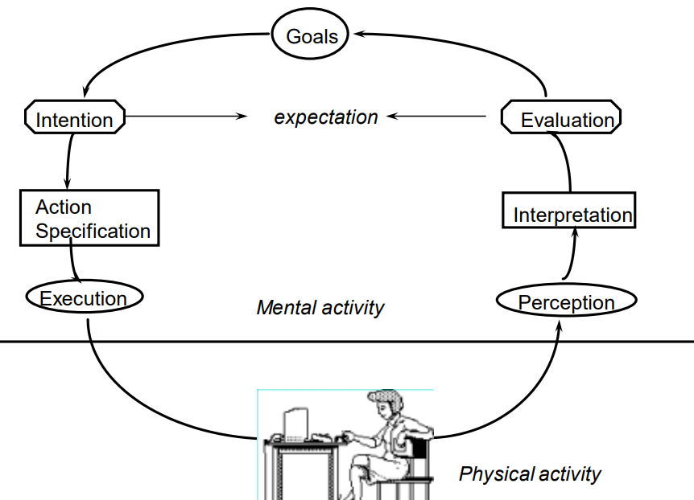

***4-stages model Norman identifies gulfs of execution and evaluation. Explain these issues.***

Gulf of Execution – do actions provided by system correspond to the intentions of the user? – Gulf: amount of effort exerted to transform intentions into selected and executed actions (should be as low as possible) A good system: direct mappings between Intention and selections – e.g. printing a letter

Gulf of Evaluation – can feedback be interpreted in terms of intentions and expectations?

– Gulf: amount of effort exerted to interpret feedback

A good system: feedback easily interpreted as task expectations – e.g. graphical simulation of text page being printed

A bad system: no feedback or difficult to interpret feedback – e.g. Unix: “$”, “bus error”, “command not found”

***4-stages Norman model supports design solution by raising and considering questions on visibility, quality of conceptual model, good mappings a high-quality feedback. Explain, comment, give examples.***

– visibility

user can see state of application and alternatives for actions

– good conceptual model

consistency in presentations of operations and results, coherent system image

– good mappings

relations between, actions and results, controls and their effects, system state and what is visible

– feedback

full and continuous feedback about results of actions

examples: whatever

***_______________________***

***User centered design***

***Explain the difference between system-centered and user-centered design.***

System Centered Design:

What can I easily build on this platform?

What can I create from the available tools?

What do I as a programmer find interesting?

User Centered System Design

Design is based upon a user’s

– abilities and real needs

– context

– work

– tasks

– need for usable and useful product

Golden rule of interface design: ***Know The User***

-based on understanding the domain of work or play in which people are engaged and in which they interact with computers

Assumptions

– The result of a good design is a satisfied customer

– The process of design is a collaboration between designers and customers. The design evolves and adapts to their changing concerns, and the process produces a specification as an important byproduct

– The customer and designer are in constant communication

***What is participatory design, positives and negatives.***

Users are 1st class members in the design process

– active collaborators or passive participants

Users considered subject matter experts

– know all about the work context

Design is iterative process

– all design stages subject to revision

Up side

– users are excellent at reacting to suggested system designs

– users bring in important “folk” knowledge of work context, may be otherwise inaccessible to design team

– greater buy-in for the system often results

Down side

– hard to get a good pool of end users – expensive, reluctance …

– users are not expert designers, don’t expect them to come up with design ideas from scratch

– the user is not always right, don’t expect them to know what they want

***Methods for involving a user - explaining design, visualization, sketching and prototyping. Describe these techniques and their usage in early and late design stages.***

Explaining designs – describe what you’re going to do and get input from the user, all design is always subject to change

-usable at all stages of the design process

Visualizations – early prototypes, important, show the user how the thing is going to look, people react differently to visuals than to just verbal descriptions/explanations

Sketches / low / medium / high fidelity prototypes

– as investment in design increases, so does the formality of the criteria whereby concepts are reviewed or accepted

– similarly, interface design (idea generation) progresses to usability testing (idea debugging and refinement)

In human language, it’s best to make lost of sketches/lo-fi prototypes early when we’re not very invested in the project and move to higher-fidelity when we already have a good foundation laid out that is likely not going to change. Investing a lot in an idea that gets scrapped is a waste of time and money

***Explain the following attributes of sketches in the design process: quick, timely, disposable, plentiful, clear vocabulary, constrained resolution, consistency with state, suggesting and exploring.***

Quick – to make

Timely – provided when needed

Disposable – investment in the concept, not the execution

Plentiful – they make sense in a collection or series of ideas

Clear vocabulary – rendering & style indicates it’s a sketch, not an implementation

Constrained resolution – doesn’t inhibit concept exploration

Consistency with state – refinement of rendering matches the actual state of development of the concept

Suggest & explore rather than confirm – value lies in suggesting and provoking what could be i.e., they are the catalyst to conversation and interaction

***When designing we use prototypes with a constrained functionality (horizontal, vertical, scenarios). Explain the differences and usage.***

vertical prototypes

– includes in-depth functionality for only a few selected features

– common design ideas can be tested in depth

horizontal prototype

– only to show the entire surface interface with no underlying functionality

– a simulation; no real work can be performed

***___________________________***

***Brain Computer Interfaces***

***What are brain computer interfaces?***

Brain-Computer Interface (BCI) or Brain– Machine Interface (BMI), is a direct way of communication between the brain and a computer system

-Invasive

-Partially-Invasive

-Non-Invasive

***What is the electroencephalogram? What are the main principles of EEG? What is the 10-20 system?***

Electroencephalography (EEG) is an electrophysiological monitoring method to record electrical activity of the brain. It is typically noninvasive, with the electrodes embedded in a special cap placed on the head. Electroencephalogram is a record of this activity.

The international 10-20 system describes the electrode placement on the scalp for EEG tests or experiments.

***What are the three main types of EEG-based BCIs?***

Depending on what kind of brain activity they listen for:

-Event related potential (P300) – Reflect processes involved in stimulus evaluation or categorization

-Sensorimotor rhythms (SMR) – Oscillatory idle rhythm of synchronized electromagnetic brain activity

-Steady State Visually Evoked Potentials (SSVEP) – Signals that are natural responses to visual stimulation at specific freq

***What is BCI illiteracy and how to improve it?***

Illiteracy means that a BCI user can’t learn how to reliably control it, affects around 20% of users

How to Improve BCI Illiteracy:

Improve classification accuracy

Change paradigm

Change neuroimaging technique

Combine neuroimaging techniques

Combine paradigms

***Mention some case studies that BCIs can be used for HCI.***

BCI interaction in games:

Navigating a robot through a 3d maze — Cognitive functions used to move forwards/backwards, expressive functions to steer; no significant differences between testers were found

Multimodal BCI games:

Game with both BCI and non-BCI input methods — users more concentrated during the BCI phase, more relaxed during the non-BCI phase

Neurogaming & Brain-Controlled Virtual Environments:

BCI’s used as primary input, excludes the use of traditional controllers — two user groups based on previous gaming experience, tested whether gamers are better at adapting to BCIs

-Enhanced sensorimotor capability of experienced gamers is partially reflected in MI-BCI training

Examining Brain Activity While Playing Computer Games:

Analyzing data recorded while participants were engaged in playing popular computer games - TrackMania Nations, Quake 3, Minesweeper

-Results revealed that the highest Alpha and Beta rhythm magnitude levels are obtained when playing Quake 3, no significant differences between noisy and quiet environments

Understanding Body Ownership in VR/AR:

Examining the use of body ownership in real environment, virtual environment and augmented reality environment

-Makes use of the rubber hand illusion (vygooglite si to), but in VR

User Profiling for BCIs and Games:

Investigating the Effect of User Profile during Training for BCI based Games, illustrates the importance of user-related effects time-related effect and the effect of reported workload immersion during game play

-Overall, this study showcased that gender, role and time have a significant effect not only on EEG modulation but also on reported workload and loss of self-consciousness during the game play. This demonstrates how sensitive BCI interaction can be, easily affected by insufficient attention due to user distraction or frustration

***What is bio-feedback?***

Biofeedback is the process of gaining greater awareness of many physiological functions primarily using instruments that provide information on the activity of those same systems, with a goal of being able to manipulate them at will. Some of the processes that can be controlled include brainwaves, muscle tone, skin conductance, heart rate and pain perception.

***____________________________***

***Evaluating interfaces with users***

***Evaluating interfaces with users is applied in all stages of project lifecycle. What are the main goals in following stages: pre-design, initial design, iterative design, acceptance testing ?***

Pre-design – Investing in new expensive system requires proof of viability

Initial design – Develop and evaluate initial design ideas with the user design evaluation implementation Importance

Iterative design – Does system behavior match the user’s task requirements? – Are there specific problems with the design? – What solutions work?

Acceptance testing – Verify that system meets expected user performance criteria

***What are the differences between naturalistic and experimental approaches to evaluation ? Explain tradeoffs and external and internal validity of testing.***

Naturalistic Approach:

Observation occurs in realistic setting – Real life

Problems:

– Hard to arrange and do

– Time consuming

– May not generalize

Experimental Approach:

– Experimenter controls all environmental factors

– Study relations by manipulating independent variables

– Observe effect on one or more dependent variables

– Nothing else changes

Validity

External validity:

Confidence that results applies to real situations, usually good in natural settings

Internal validity:

Confidence in our explanation of experimental results, usually good in experimental settings

Trade-off: Natural vs Experimental:

Precision and direct control over experimental design vs. Desire for maximum generalizability in real life situations

***Usability evaluation applies low cost methods, such as inspection, extracting the conceptual model, observation, query techniques and continuous evaluation. Characterize these techniques and discuss pros and cons.***

Inspection:

Designer tries the system (or prototype) – Does the system “feel right”?

– Benefits: Can catch some major problems in early versions

– Problems: Not reliable and completely subjective

Not valid as introspector is a non-typical user

Intuitions and introspection are often wrong

Model extraction:

Show the user static images of the prototype or screens during use, ask the user to try to explain the function of each screen element, how they would perform a particular task

Initial conceptual model: How person perceives a screen the very first time it is viewed

Formative conceptual model: How person perceives a screen after its been used for a while

Good for eliciting people’s understanding before & after use

Poor for examining system exploration and learning

Observation:

Evaluator observes users interacting with system

– In lab: User asked to complete a set of pre-determined tasks

– In field: User goes through normal duties

Value – Excellent at identifying gross design/interface problems

– Validity depends on how controlled/contrived the situation is

Problem – Does not give insight into the user’s decision process or attitude

Think Aloud Method:

Users speak their thoughts while doing the task, what they are trying to do, why they took an action, how they interpret what the system did

pro: – gives insight into what the user is thinking

– most widely used evaluation method in industry

con: – may alter the way users do the task

– unnatural (awkward and uncomfortable)

– hard to talk if they are concentrating

Query techniques:

Give the user questions, do interviews

Good for pursuing specific issues

– Vary questions to suit the context

– Probe more deeply on interesting issues as they arise

– Good for exploratory studies via open-ended questioning

– Often leads to specific constructive suggestions

Problems:

– Accounts are subjective

– Time consuming

– Evaluator can easily bias the interview

– Prone to rationalization of events/thoughts by user

– User’s reconstruction may be wrong

– Sometimes difficult to find people!

***Explain the basic ethic principles before testing: user's time, comfort, privacy, informing, volunteering.***

Don’t waste the user’s time

– Use pilot tests to debug experiments, questionnaires etc

– Have everything ready before the user shows up

Make users feel comfortable

– Emphasize that it is the system that is being tested, not the user

– Acknowledge that the software may have problems

– Let users know they can stop at any time

Maintain privacy

– Tell user that individual test results will be completely confidential

Inform the user

– Explain any monitoring that is being used

– Answer all user’s questions (but avoid bias)

Only use volunteers

– User must sign an informed consent form

***Explain the basic ethic principles during testing: user's time, comfort, privacy.***

Don’t waste the user’s time

– Never have the user perform unnecessary tasks

Make users comfortable

– Try to give user an early success experience

– Keep a relaxed atmosphere in the room

– Coffee, breaks, etc

– Hand out test tasks one at a time

– Never indicate displeasure with the user’s performance

– Avoid disruptions

– Stop the test if it becomes too unpleasant

Maintain privacy

– Do not allow the user’s management to observe the test

***Explain the basic ethic principles after testing: comfort, privacy, informing.***

Make the users feel comfortable

– State that the user has helped you find areas of improvement

Inform the user

– Answer particular questions about the experiment that could have biased the results before

Maintain privacy

– Never report results in a way that individual users can be identified

– Only show videotapes outside the research group with the user’s permission

**______________________________**

***Evaluation - Controlled experiments***

***Controlled experiment focuses on: hypothesis, measurement, confidence, replicability, control of variables and conditions, unbiased execution. Comment and explain the issues.*** (o replicability a control of variables sa v príslušných slajdoch nič nepíše, ale asi sa dá niečo domyslieť)

Controlled experiments strive for:

– Clear and testable hypothesis:

-a precise problem statement • Example: – There is no difference in user performance (time and error rate) when selecting a single item from a pop-up or a pull down menu of 4 items, regardless of the subject’s previous expertise in using a mouse or using the different menu types

a hypothesis ncludes independent and dependent variables

indep.: The things you manipulate independent of a subject’s behaviour, determines a modification to the conditions the subjects undergo; Menu type: pop-up or pull-down – Menu length: 3, 6, 9, 12, 15 – Subject type (expert or novice)

dep.: Variables dependent on the subject’s behaviour/reaction to the independent variable, The specific things you set out to quantitatively measure/observe; Time to select an item – Selection errors made – Time to learn to use it to proficiency

– Quantitative measurement

Four major scales of measurements – Nominal – Ordinal – Interval – Ratio

Nominal Scale

- classification into named or numbered unordered categories – Country of birth, user groups, gender…

-statistics - number of items in category, most populous category...

-sources of error – Agreement in labelling, vague labels, vague differences in objects

-testing for error – Agreement between different judges for same object

Ordinal Scale

-classification into named or numbered ordered categories – No information on magnitude of differences between categories, i.e. Preference, social status, gold/silver/bronze medals

-transitive: if A > B > C, then A > C

-statistics – median, percentiles…

-sources of error – As in nominal

Interval Scale

-classification into ordered categories with equal differences between categories

-zero only by convention i.e. temperature (C,F), time of day

-statistics – Mean, standard deviation, range, variance

-sources of error – Instrument calibration, reproducibility and readability – Human error, skill…

Ratio Scale

-interval scale with absolute, non-arbitrary zero – i.e. temperature (K), length, weight, time periods

– Measure of confidence in results obtained (statistics)

Confidence limits:

– The confidence that your conclusion is correct – “the hypothesis that computer experience makes no difference is rejected at the .05 level” means: A 95% chance that your statement is correct, a 5% chance you are wrong

Statistical analysis is used to tell us the mathematical attributes of our data sets, how they relate to each other and the probability that our claims are correct. With a large sample size, even a small deviaton between data may be statistically (but maybe not practically) significant.

– Replicability of experiment (???)

– Control of variables and conditions (???)

– Removal of experimenter bias

Strive for unbiased instructions, unbiased experimental protocols – prepare scripts ahead of time; unbiased subject selection

***Four scales of measurement are nominal, ordinal, interval, ratio. Explain briefly, give examples and consider the possible sources of errors.***

see previous question

***The following concepts are important for designing: perceived affordances, causality, visible constraints, mapping, transfer effects, idioms & population stereotypes, conceptual models, individual differences, difficulty of design. Explain the selected concepts, provide positive and negative examples.***

Perceived Affordances:

-the perceived properties of the object that suggest how one could use it

-chairs are for sitting, table for placing things on

-knobs are for turning, buttons are for pressing

-…

Actual affordances: • The actual actionable properties of the product, problems occur when PA != AA – People’s perceptions are not what the designer expects

Causality:

The thing that happens right after an action is assumed by people to be caused by that action – Interpretation of “feedback”

– False causality:

• Incorrect effect – Invoking unfamiliar function just as computer hangs

• Invisible effect – Command with no apparent result often re-entered repeatedly – e.g., mouse click to raise menu on unresponsive system

Visible Constraints:

Limitations of the actions possible perceived from object’s appearance – provides people with a range of usage possibilities

Mapping:

The set of possible relations between objects • Control-display compatibility – the natural relationship between controls and displays – e.g., visual mapping of stove control knobs to indivitual stove pads

Transfer Effects:

People transfer their learning/expectations of similar objects to the current objects

positive transfer: previous learnings also apply to new situation

negative transfer: previous learnings conflict with the new situation

Idioms and Population Stereotypes:

Interface idioms: – ‘standard’ interface features we learnt, use and remember

Idioms may define arbitrary behaviours – red means danger – green means safe

Population stereotypes: Idioms vary in different cultures

– Light switches • America: down is off • Britain: down is on

– Faucets • America: anti-clockwise on • Britain: anti-clockwise off

Conceptual model

People have “mental models” of how things work, built from – affordances – causality – constraints – mapping – positive transfer – population stereotypes/cultural standards – instructions – interactions

-Models allow people to mentally simulate operation of device, models may be wrong – particularly if above attributes are misleading

good example: scissors, bad: digital wristwatch

Individual differences:

People are different, it is rarely possible to accommodate all people perfectly – design often a compromise

Rule of thumb: – cater to 95% of audience (5th or 95th percentile), but means 5% of population may be (seriously!) compromised

– designing for the average a mistake, may exclude half the audience

Examples:

– cars and height: headroom, seat size

– computers and visibility: font size, line thickness, color for color-blind people

Why design is hard:

– over the last century, the number of things to control has increased dramatically

– display is increasingly artificial • red lights in car indicate problems vs flames for fire

– feedback more complex, subtle, and less natural

– errors increasingly serious and/or costly

– adding functionality (complexity) now easy and cheap, but adding controls/feedback expensive

– design usually requires several iterations before success

– bad design not always visible

– people tend to blame themselves when errors occur

***__________________________________________***

***Information representation and visualization***

***Visual variable attributes are: position, size, shape, value, orientation, color, texture, motion. The attributes may be selective, associative, quantitative, order, length. Comment these characteristics for the selected attributes.***

• Position – Changes in the x, y (z) location

• Size – Change in length, area or repetition

• Shape – Infinite number of shapes

• Value – Changes from light to dark

• Orientation – Changes in alignment

• Colour – Changes in hue at a given value

• Texture – Variation in pattern

• Motion

Different variable attributes may be:

– Selective • Is a change enough to allow us to select it from a group?

– Associative • Is a change enough to allow us to perceive them as a group?

– Quantitative • Is there a numerical reading obtainable from changes in this variable?

– Order • Are changes in this variable perceived as ordered?

– Length • Across how many changes in this variable are distinctions perceptible?

Pos - y: all

Size - y: SAOL, ?: Q

Shape - ?: SA, n: QO, y: L (infinite variations)

Value - y: SAOL, n: Q

Colour - y: SAL, n: OQ

***The snapshots of a given application contain visual variables with specific attributes. Mark these attributes and asses the characteristics they express.***

¯\_(ツ)_/¯

***____________________________***

***Metaphors***

***What are interface metaphors, theirs purpose and possible problems ? Comment emotional coloring, possible restrictions, typical errors of metaphors' usage.***

• Definition – Represents a system object as if it were another type of object – Disc / network file structure represented as file folders

• Purpose – Leverages our knowledge of familiar, concrete objects to understand abstract computer and task concepts

• Problem – Metaphor portrays inaccurate/naive conceptual model of the system

Emotional coloring - the “tone” of the metaphor, we should ensure it’s approriate for the user/task, e.g. file deletion - trashcan vs. nuclear disposal unit

Metaphors could restrict what the user can do by being too literal (strict file forlder hierarchy doesn’t allow user to obviously create links between files on different branches)

Typ. errors:

-Overly literal: Unnecessary fidelity, excessive interactions, nnecessary restrictions

-Overly cute: Novelty quickly wears off

-Mismatched: Does not match user’s task and/or thinking

***Explain "interface with direct manipulation" and related issues visibility, reversible and incremental actions, pointing and moving, continuous display. Provide an example of direct manipulation interface and comment where, and in what form are these notions used.***

Direct manipulation – Interface behaves as though the interaction was with a real-world object rather than with an abstract system – The feeling of working directly on the task

Central ideas – Visibility of the objects of interest – Rapid, reversible, incremental actions – Manipulation by pointing and moving – Immediate and continuous display of results

(v slajdoch podrobne nevysvetlené, dá sa to obkecať na príklade)

***Screen design can be guided by CRAP (contrast, repetition, alignment, proximity). What these principles enforce and guarantee ? Show their application on a given screen snapshot.***

(v slajdoch o CRAP nič nie je)

## *https://saylordotorg.github.io/text_business-information-systems-design-an-app-for-that/s07-01-c-r-a-p-principles-of-graphic-.html*

## 

**Contrast** focuses our attention and should be used to highlight the most important points that the audience should take away. Designers should use colors, bold type, and size to distinguish parts of text or an image and create contrast. Contrast is used in all aspects of life. For example, jewelers usually display their diamond pieces on a background of black velvet to let the jewels stand out. The page you are reading uses headings to create contrast with the text.

**Repetition** ties objects or images together. For instance, we know which football players are on a team because of the repetition of their uniforms. This text uses repetition of fonts, styles, and sizes to unify the design. On the facing page, repetition of graphic elements draws an image together.

**Alignment** indicates organization, polish, and strength. Text on a page is easier to read and understand if it is properly aligned to the margin. Alignment should be applied to every design or page layout to show order. Alignment on this page is created by left aligning all of the text and graphics.

## 

**Proximity** creates relationships within objects in an image. Placing objects close together shows their connectedness and focuses the audience’s attention. For example, captions placed near photos on a page layout show that they describe the photos they are near. The page you are reading places headings next to the text they introduce to signify their relationship.

***CRAP (contrast, repetition, alignment, proximity) may be supported by grids. Compare given screen snapshots and criticize the design using CRAP&grid principles.***

absolútne netuším, čo tými mriežkami myslí, google nepomáha

¯\_(ツ)_/¯

***_________________________***

***Cognitive models***

***Describe a general model of human processing of external information. Explain the cooperation of perceptual, cognitive and motor systems during interaction. Discuss how the parameters memory capacity, decay, representation and processing cycle time influence interaction. Explain the model with a given example.***

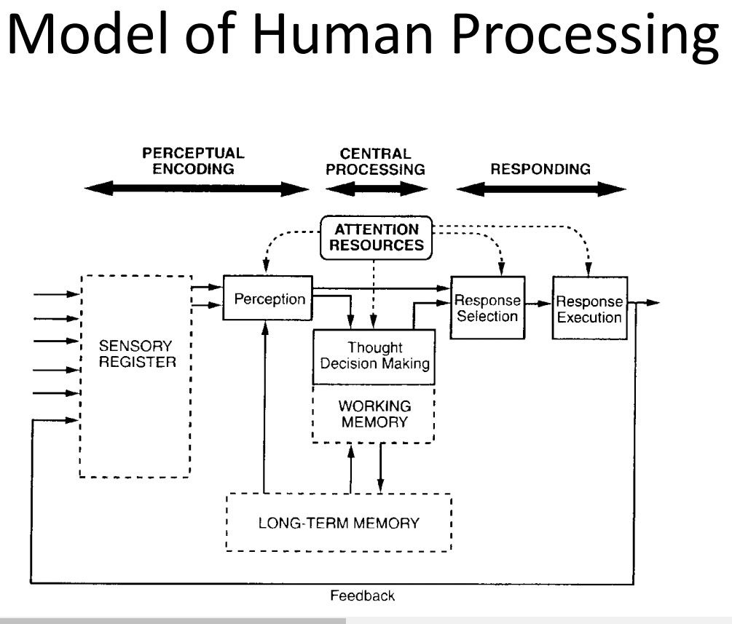

Task: Press button when symbol appears

• 1. The perceptual processor captures it in the visual image store and represents it in working memory – 100 [50~200]

• 2. The cognitive processor recognizes the presence of a symbol – 70 [25~170]

• 3. The motor processor pushes the button – 70 [30~100]

***Reaction time is closely related to decision-making. What are the factors influencing decision time ? Explain Hick-Hyman law of reaction time.***

The speed with which an action can be selected is strongly influenced by the number of possible alternative actions that could be selected

• Hick-Hyman Law of reaction time shows a logarithmic increase in reaction time (RT) as the number of possible stimulus-response alternatives (N) increases – Humans process information at a constant rate

RT = a + bLog2N

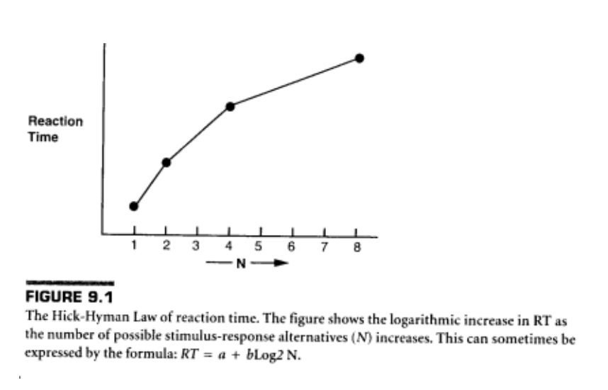

***Explain Fitt's law, give examples.***

Models movement time for selection tasks

The movement time for a well-rehearsed selection task increases as the distance to the target increases and decreases as the size of the target increases

Time (in msec) = a + b log2 (D/S+1)

where a, b = constants (empirically derived)

D = distance

S = size

ID is Index of Difficulty = log2 (D/S+1)

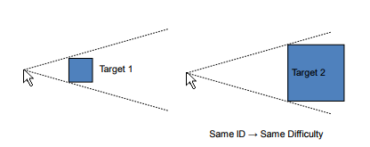

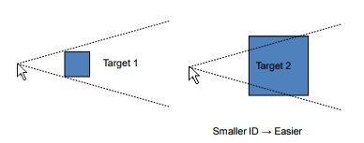

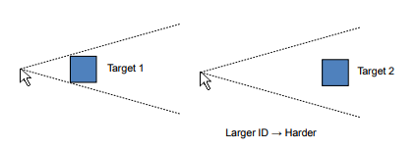

***Compare KLM and GOMS models. Comment their usage in practice.***

KLM:

Keystroke-Level Model

Main idea:

– Walk through the interface, counting how many operations it would take an expert user to perform

– Look for ways to optimize

– Look for potential sources of error

• KLM is very low-level (tiny operations)

How to make a KLM

– List specific actions user does to perform task

• Keystrokes and Button presses

• Mouse movements / Pointing

• Hand movements between keyboard & mouse / Homing

• Drawing

• System Response time (if it makes user wait)

– Add Mental operators

– Assign execution times to steps

– Sum execution times

• Only provides execution time and operator sequence

GOMS:

A family of user interface modeling techniques

• Goals, Operators, Methods, and Selection rules

– Higher-level than KLM

– Input: detailed description of UI and task(s)

– Output: various qualitative and quantitative measures

Goal - what the user wants to achieve

Operator - elementary perceptual, motor, or cognitive act

Method - a series of operators that forms a procedure for doing something

Selection rule - how the user decides between methods (if...then...)

Used for:

Comparing UI designs

Profiling

Building a help system

– GOMS modeling makes user tasks and goals explicit

– Can suggest questions users will ask and the answers

-GOMS not used often in practice

***_____________________***

***Heuristic evaluation***

***For evaluating interfaces various criteria may be used, such as following heuristics:***

***simple and natural dialog***

***user's language***

***minimization of memory load***

***consistency***

***feedback***

***clearly marked exits***

***shortcuts***

***positive error solution***

***offered help***

***Evaluate a selected application given several screen snapshots.***

¯\_(ツ)_/¯

(príklady jednotlivých kategórii v slajdoch, ale dá sa to domyslieť)